The Instructional Profile of the Sermon on the Mount: A Conservative Evangelical AI-Assisted Proposition-Level Analysis of Matthew 5-7
  - Final academic report and public dataset documentation
NT Discipleship Research Project | Release v1.0-AI-ECR | 31 July 2026
Release classification
This publication reports a finalized AI-reviewed conservative evangelical dataset. The review was completed under a grammatical-historical, free-choice/non-Calvinist, conditional-security, moderately dispensational, and cautiously continuationist framework. It is not human peer review and is not human inter-annotator reliability evidence.

Abstract
This study presents a proposition-level analysis of instructional material in Matthew 5-7. The final release contains 179 central instructional propositions linked to 213 preserved historical occurrence records through 220 explicit cross-references. Each proposition is classified by evidence type, instructional form, polarity, scope, temporal force, normativity, command family, topic, soteriological relation, canonical status, textual-control links, and mapping status. Two completed AI reviews under a consolidated conservative evangelical protocol accepted all 179 central propositions without revision and confirmed all 45 mapping controls provisionally. The resulting v1.0-AI-ECR release identifies the Sermon on the Mount as a densely structured body of kingdom instruction integrating character, inward righteousness, Father-centered piety, prayer, possessions, trust, community ethics, discernment, perseverance, judgment, and obedience to Jesus' words. Textual and historical claims remain bounded by explicit source-access limitations.

1. Introduction
The Sermon on the Mount is frequently summarized through selected themes or familiar imperatives. This project instead asks what instructional content is present across the whole literary corpus, how that content is grammatically expressed, how it clusters into command families and topics, and how warning, promise, character, obedience, reward, perseverance, and judgment relate within the discourse.
The study is intentionally biblical and academic rather than pastoral. It seeks to preserve the literary sequence and grammatical force of Matthew 5-7 while making the resulting dataset usable for exegetical, biblical-theological, and systematic analysis.

2. Research questions
- What discrete instructional propositions are expressed or authoritatively implied in Matthew 5-7?
- How are these propositions distributed among commands, prohibitions, warnings, virtues, promises, rationales, and narrative evaluations?
- Which command families and theological topics dominate the discourse?
- How do normativity, canonical continuity, and soteriological relations function across the corpus?
- What textual and mapping uncertainties remain after the finalized AI-ECR review?

3. Corpus and data architecture
The corpus comprises thirty literary units. Matthew 5:1-2 functions as a narrative setting and contains no central instructional proposition in the final register. The remaining twenty-nine units contain 179 central propositions. The historical layer preserves 213 first-pass OCC-MT records; the central layer consolidates or repartitions these into CEN-MT propositions without deleting or renumbering the historical identifiers.
Layer | Records | Purpose
Historical occurrence layer | 213 | Preserves the first-pass project history and original OCC-MT identifiers.
Central proposition layer | 179 | Provides the finalized proposition-level analytical release.
Occurrence-central links | 220 | Makes merges, splits, and repartitions explicit.
Textual issue controls | 68 | Preserves wording and semantic-scope questions without inventing apparatus evidence.
Mapping controls | 45 | Records the historically unresolved mappings confirmed provisionally in the AI-ECR release.

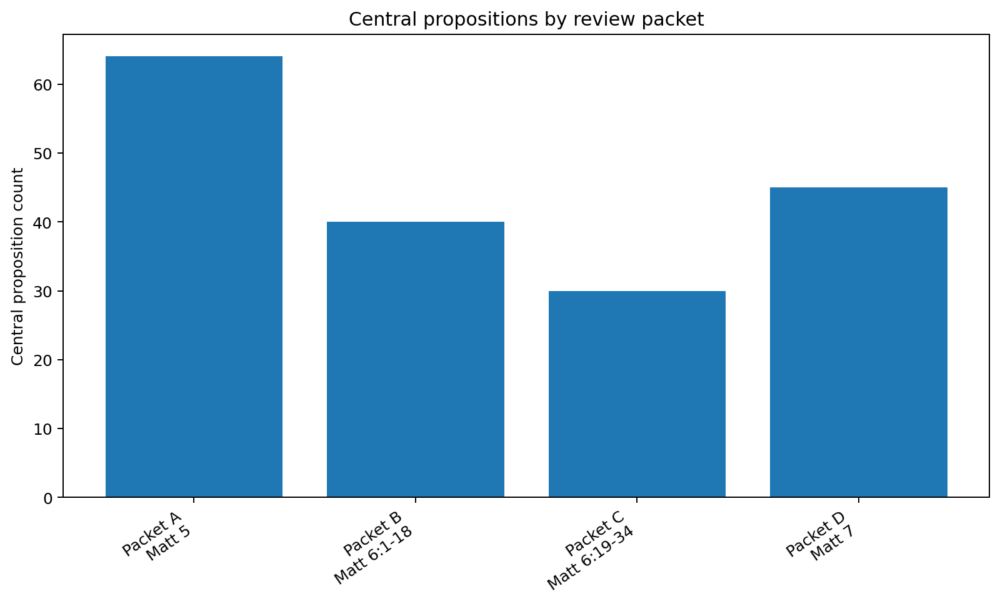
Figure 1. Central propositions by external-review packet.

4. Methodology

4.1 Proposition segmentation
Instructional propositions were segmented at the level required to preserve grammatical force, logical relations, and distinct outcomes. Directives were not treated as the only instructional form. Beatitudes, warnings, promises, identity declarations, divine actions, necessity statements, rationales, and narrative evaluations were retained where they carry normative or interpretive force.

4.2 Theological and hermeneutical controls
- Scripture is treated as inspired, inerrant in the autographs, authoritative, and the final interpretive norm.
- The grammatical-historical method governs literary and original-language analysis.
- Commands, invitations, choices, warnings, and perseverance are treated as genuine moral and covenantal realities rather than predetermined appearances.
- Judgment and apostasy warnings are not neutralized by an automatic unconditional-security assumption.
- Moderate dispensational distinctions are preserved without removing the Sermon from Christian discipleship.
- Spiritual gifts are neither assumed to have ceased nor accepted as self-authenticating.
- Ancient sources, lexicons, commentaries, and AI outputs remain subordinate to Scripture.

4.3 Review and release protocol
Pilot 40 established a single consolidated review bundle. CODX01 and META01 each completed that bundle. Both accepted all 179 propositions and retained all 45 candidate mappings. The second return served as supplementary corroboration rather than creating a continuing independent-review requirement.

4.4 Counting controls
- A central proposition count measures analytical segmentation, not theological importance.
- Topic counts distinguish primary membership from inclusive primary-plus-secondary membership.
- Soteriological relations are multi-label; their counts therefore exceed 179 when summed.
- Historical occurrence counts and central proposition counts are intentionally reported separately.
- Textual main-text observations are not represented as full critical-apparatus adjudication.

5. Results

5.1 Distribution by chapter and packet
Chapter_Group | Central_Propositions | Direct_Imperatives | Prohibitions | Warnings_or_Conditions | Universal_Enduring | Leading_Primary_Topic | Leading_Topic_Count | Leading_Command_Family | Leading_Family_Count
Matthew 5 | 64 | 9 | 8 | 22 | 52 | Kingdom and righteousness | 8 | Kingdom character beatitudes | 7
Matthew 6 | 70 | 21 | 8 | 25 | 53 | Anxiety, trust, and providence | 16 | Divine reward for hidden faithfulness | 10
Matthew 7 | 45 | 6 | 6 | 25 | 43 | Petition, persistence, and paternal goodness | 9 | Ask, seek, and knock with persevering filial confidence | 6

Matthew 5 contains 64 central propositions, Matthew 6 contains 70, and Matthew 7 contains 45. The largest single pericope is Matthew 6:25-34, with eighteen central propositions, reflecting the density of prohibitions, providential rationales, comparisons, kingdom priority, and temporal instruction.

5.2 Instructional evidence types
Evidence type | Count | Percent
Warning or condition | 72 | 40.22%
Direct imperative | 36 | 20.11%
Virtue norm | 24 | 13.41%
Prohibition | 22 | 12.29%
Authoritative exemplar | 8 | 4.47%
Divine-will statement | 8 | 4.47%
Necessity statement | 4 | 2.23%
Role-specific directive | 3 | 1.68%
Narrative norm candidate | 2 | 1.12%

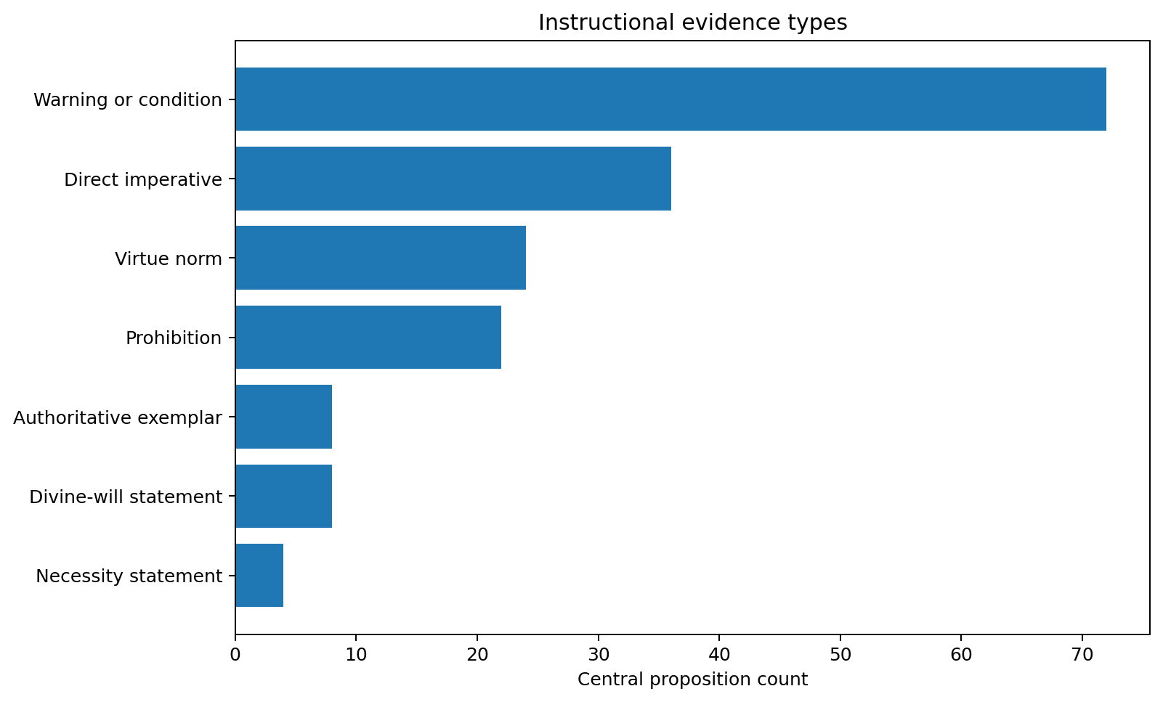
Figure 2. Distribution of instructional evidence types.
Warnings or conditions form the largest category at 72 propositions. Direct imperatives and prohibitions account for 58 propositions, with three additional role-specific directives. The dataset therefore demonstrates that Jesus' instruction cannot be reduced to imperative counting: warnings, promises, identity, virtue, and rationale are integral to the discourse's normative force.

5.3 Normativity, polarity, and scope
Normativity | Count | Percent
Universal enduring | 148 | 82.68%
Universal principle with variable expression | 21 | 11.73%
Corporate | 10 | 5.59%

Polarity | Count | Percent
Positive | 130 | 72.63%
Negative | 45 | 25.14%
Mixed | 4 | 2.23%

The release classifies 148 propositions as universally enduring, twenty-one as universal principles with variable expression, and ten as corporate forms. Positive propositions substantially outnumber negative ones, although the forty-five negative and four mixed propositions preserve the Sermon's strong prohibitions and warnings.

5.4 Command families
ID | Command family | Central count | Pericopes | Directives/prohibitions
CF-MT-023 | Divine reward for hidden faithfulness | 10 | 4 | 0
CF-MT-037 | Consider providence, creaturely dependence, and greater human value | 9 | 1 | 2
CF-MT-001 | Kingdom character beatitudes | 7 | 1 | 0
CF-MT-003 | Public kingdom witness and doxology | 7 | 1 | 0
CF-MT-036 | Trustful freedom from anxiety about necessities and tomorrow | 7 | 1 | 2
CF-MT-013 | Reject manipulative and creature-based oaths | 6 | 1 | 5
CF-MT-043 | Ask, seek, and knock with persevering filial confidence | 6 | 1 | 3
CF-MT-033 | Heavenly treasure and heart allegiance | 5 | 1 | 2
CF-MT-046 | Enter the narrow gate and persevere on the way of life | 5 | 1 | 1
CF-MT-048 | Recognize prophetic and teaching claims by tested fruit | 5 | 1 | 0
CF-MT-002 | Faithful response to persecution | 4 | 1 | 0
CF-MT-007 | Murder, anger, and contempt | 4 | 1 | 0
CF-MT-011 | Radical removal of sexual stumbling under Gehenna warning | 4 | 1 | 2
CF-MT-018 | Neighbor-love extended to enemies | 4 | 1 | 1
CF-MT-026 | Reject empty verbosity and trust the Father's prior knowledge | 4 | 1 | 2

The largest command family concerns divine reward for hidden faithfulness, followed by providential reasoning in Matthew 6:25-34. The leading families also include kingdom-character beatitudes, public witness, freedom from anxiety, truthful speech, persevering prayer, heavenly treasure, the narrow gate, and fruit-based discernment.

5.5 Topic profile
ID | Topic | Primary | Inclusive | Pericopes
T011 | Prayer | 12 | 26 | 4
T008 | Kingdom and righteousness | 14 | 17 | 4
T031 | Eschatological readiness, reward, and judgment | 10 | 16 | 6
T036 | Anxiety, trust, and providence | 16 | 16 | 1
T021 | Generosity, wealth, and possessions | 10 | 12 | 3
T010 | Mind, heart, conscience, and affections | 9 | 11 | 5
T022 | Speech ethics | 8 | 10 | 2
T039 | Petition, persistence, and paternal goodness | 9 | 9 | 1
T014 | Mission and witness | 7 | 7 | 1
T037 | Judgment, self-examination, and restoration | 7 | 7 | 1
T042 | False prophecy, fruit testing, and leader accountability | 7 | 7 | 1
T023 | Sexual ethics and bodily holiness | 6 | 6 | 1
T034 | Humility, unity, and peace | 2 | 6 | 2
T005 | Love | 4 | 5 | 1
T012 | Worship, thanksgiving, and doxology | 0 | 5 | 2

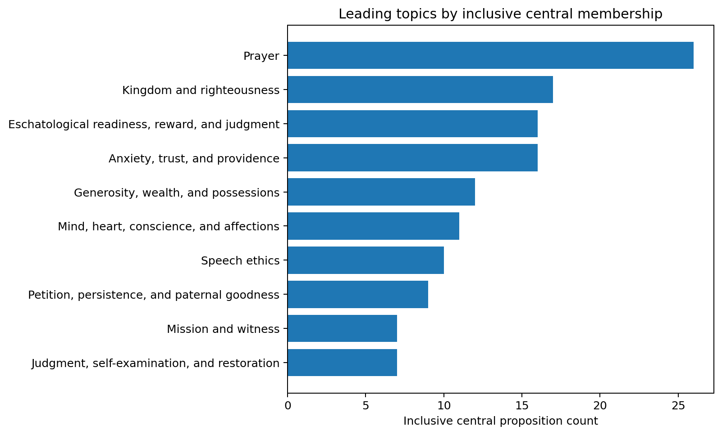
Figure 3. Leading topics by inclusive central-proposition membership.
Prayer has the largest inclusive membership at twenty-six propositions. Kingdom and righteousness follow at seventeen, while eschatological readiness, reward, and judgment and anxiety, trust, and providence each have sixteen. The prominence of prayer, kingdom priority, judgment, providence, possessions, inward disposition, and speech shows that the Sermon's ethical vision is simultaneously God-centered, eschatological, relational, and materially embodied.

5.6 Soteriological relation profile
Relation | Count | Percent | Note
Means of perseverance | 86 | 48.04% | Multi-label frequency; percentages do not sum to 100.
Evidence | 76 | 42.46% | Multi-label frequency; percentages do not sum to 100.
Fruit | 62 | 34.64% | Multi-label frequency; percentages do not sum to 100.
No direct soteriological relation | 61 | 34.08% | Multi-label frequency; percentages do not sum to 100.
Fellowship-related | 37 | 20.67% | Multi-label frequency; percentages do not sum to 100.
Reward-related | 18 | 10.06% | Multi-label frequency; percentages do not sum to 100.
Continuing condition | 14 | 7.82% | Multi-label frequency; percentages do not sum to 100.
Merit explicitly excluded | 8 | 4.47% | Multi-label frequency; percentages do not sum to 100.
Discipline-related | 5 | 2.79% | Multi-label frequency; percentages do not sum to 100.
Initial condition | 5 | 2.79% | Multi-label frequency; percentages do not sum to 100.

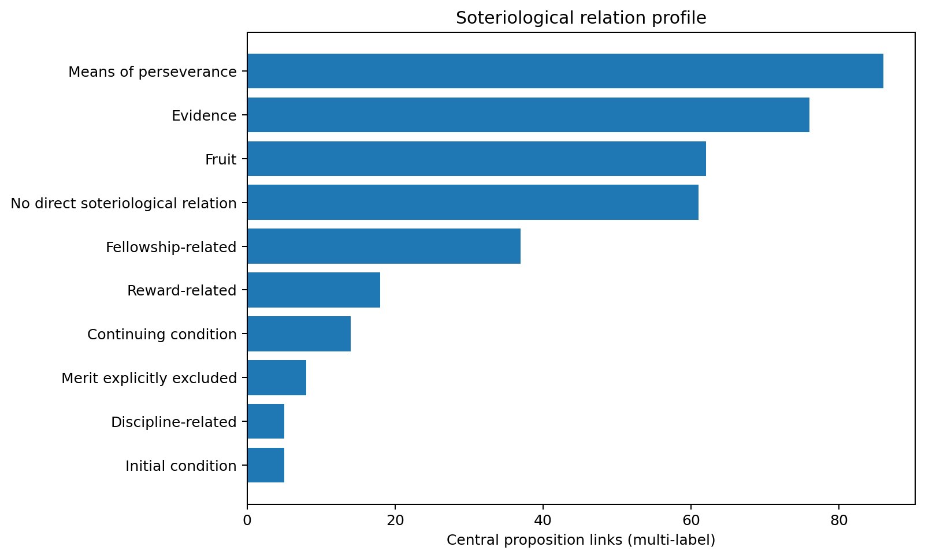
Figure 4. Multi-label soteriological relation frequencies.
Means of perseverance, evidence, and fruit are the most frequent soteriological relations. Fourteen propositions are classified as continuing conditions and five as initial conditions, while eight explicitly exclude merit. This pattern supports a conditional-security reading without converting obedience into meritorious self-salvation: the text presents faithful response, fruit, perseverance, and warning as real while grounding salvation in divine grace.

6. Theological profiles

6.1 Kingdom, righteousness, and fulfillment
Kingdom and righteousness unite the Beatitudes, the fulfillment of the Law and Prophets, the model prayer, and the priority of seeking God's reign and righteousness. The canonical-status profile classifies 111 propositions as directly reaffirmed, thirty-six as reaffirmed in principle, twenty-three as intensified, and nine as Christologically transformed. The pattern preserves continuity in God's moral purposes while recognizing Jesus' authoritative fulfillment and interpretation.

6.2 Inward righteousness and embodied obedience
The Sermon moves from murder to anger and contempt, from adultery to purposive desire, from oath manipulation to truthful speech, and from neighbor-love to enemy-love. This is not a retreat from conduct into inward sentiment. The heart and body are integrated: inward intention generates accountable speech, reconciliation, sexual holiness, nonretaliation, generosity, prayer, fasting, and visible good works.

6.3 Father-centered piety
Matthew 6 organizes almsgiving, prayer, forgiveness, fasting, possessions, and anxiety around the Father's knowledge, presence, reward, provision, and will. Hidden faithfulness is contrasted with audience-directed display. The model prayer orders petition around God's name, kingdom, will, provision, forgiveness, and deliverance.

6.4 Free choice, genuine responsibility, and conditional security
The large number of directives, prohibitions, warnings, and conditions is treated as genuine moral address. Salt may become useless; anger, lust, unforgiveness, divided service, false profession, corrupt fruit, lawlessness, and foundationless hearing carry real consequences. Narrow-gate entry, doing the Father's will, hearing and doing Jesus' words, and persevering on the way of life are not reduced to hypothetical descriptions of an outcome fixed independently of response.
At the same time, the release distinguishes fruit, evidence, perseverance, fellowship, discipline, reward, initial response, and continuing conditions. It does not treat obedience as autonomous merit or as a replacement for grace.

6.5 Moderate dispensational continuity
The analysis preserves Israel, nations, and church distinctions without placing the Sermon outside Christian discipleship. Jesus fulfills rather than abolishes the Law and Prophets, discloses their moral intent, and authoritatively directs his disciples. Later canonical reauthorization is classified proposition by proposition rather than assumed through either covenantal flattening or hyper-dispensational exclusion.

6.6 Cautious continuationism and discernment
Matthew 7:15-23 requires discernment of prophets, teachers, and extraordinary ministry claims by fruit, the Father's will, Jesus' relational knowledge, and freedom from lawlessness. Prophecy, exorcism, and mighty works are not treated as impossible, but neither are they self-authenticating. This coheres with a cautious continuationist framework governed by Scripture and moral fruit.

6.7 Christological authority
The concluding narrative identifies the distinguishing feature of the Sermon as Jesus' authority. The final foundation sayings place wisdom and eschatological stability in hearing and doing his words. The discourse is therefore not merely a collection of general moral principles; it is authoritative kingdom instruction centered on allegiance and obedience to Jesus.

7. Textual and mapping controls
Textual status | Count
Blank source placeholders preserved as N/A | 43
Textual issues unresolved without direct apparatus verification | 18
Semantic controls accepted with textual-verification limitation | 7

No textual issue produced a revision to the 179 central propositions. The release does not claim direct verification of licensed NA28, UBS5, or UBS6 apparatus entries where those were not inspected. Preferred critical or source-text wording is retained provisionally, and semantic-control issues are separated from manuscript-attestation claims.
All forty-five mapping controls were confirmed provisionally by both integrated AI reviewers. Their limitation remains explicit: the exact Pilot 27 occurrence wording was not mounted in the reviewers' environments. The mappings are suitable for the AI-ECR release but remain identified as provisional rather than silently converted into human-adjudicated facts.

8. Reliability and limitations
- The release is AI-reviewed and must not be described as human peer review.
- The exact agreement between CODX01 and META01 is corroborative AI convergence, not human inter-annotator reliability.
- Counts depend on the project's proposition-segmentation rules and should not be mistaken for inspired numerical priorities.
- Original-language and textual-critical conclusions are limited by the sources explicitly consulted.
- Forty-three textual-control rows lack source metadata and are retained as transparent N/A placeholders.
- Ancient and modern scholarly sources remain subordinate to Scripture and were not exhaustively surveyed in this release.
- The dataset represents a declared conservative evangelical framework rather than a claim to theological neutrality.

9. Conclusion
The final dataset portrays the Sermon on the Mount as comprehensive discipleship instruction structured by kingdom character, surpassing righteousness, Father-centered devotion, truthful and reconciling relationships, sexual and bodily holiness, enemy-love, generosity, prayer, providential trust, self-examination, discernment, perseverance, judgment, and obedience to Jesus. The prominence of warnings and conditions does not erase grace; it shows that grace addresses responsible persons and forms persevering disciples. The prominence of promises, Fatherly provision, reward, and divine action prevents the ethical demands from becoming autonomous moralism.
The v1.0-AI-ECR release provides a reproducible public data structure for further academic analysis while maintaining explicit limits around AI review, textual apparatus access, and provisional historical mappings.

Appendix A. Pericope-level results
ID | Reference | Title | Historical | Central | Imperatives | Prohibitions | Warnings | Leading topic
MT-SM-001 | Matthew 5:1-2 | Narrative setting: Jesus ascends, sits, and teaches | 0 | 0 | 0 | 0 | 0
MT-SM-002 | Matthew 5:3-12 | Beatitudes and persecution | 10 | 11 | 0 | 0 | 2 | Kingdom and righteousness
MT-SM-003 | Matthew 5:13-16 | Salt and light | 3 | 7 | 0 | 0 | 4 | Mission and witness
MT-SM-004 | Matthew 5:17-20 | Law, Prophets, and greater righteousness | 5 | 6 | 0 | 1 | 3 | Scripture, truth, and teaching
MT-SM-005 | Matthew 5:21-26 | Murder, anger, and reconciliation | 9 | 8 | 2 | 0 | 5 | Mind, heart, conscience, and affections
MT-SM-006 | Matthew 5:27-30 | Adultery, desire, and radical removal of sin | 6 | 6 | 2 | 0 | 3 | Sexual ethics and bodily holiness
MT-SM-007 | Matthew 5:31-32 | Divorce | 3 | 3 | 0 | 0 | 2 | Marriage, family, and household
MT-SM-008 | Matthew 5:33-37 | Oaths and truthful speech | 9 | 8 | 1 | 5 | 1 | Speech ethics
MT-SM-009 | Matthew 5:38-42 | Retaliation and generous nonretaliation | 7 | 7 | 1 | 2 | 0 | Mercy and justice
MT-SM-010 | Matthew 5:43-48 | Enemy-love and likeness to the Father | 9 | 8 | 3 | 0 | 2 | Love
MT-SM-011 | Matthew 6:1 | Controlling principle for public righteousness | 2 | 2 | 0 | 1 | 1 | Mind, heart, conscience, and affections
MT-SM-012 | Matthew 6:2-4 | Almsgiving before the Father | 6 | 6 | 2 | 0 | 2 | Generosity, wealth, and possessions
MT-SM-013 | Matthew 6:5-6 | Prayer without display | 8 | 8 | 2 | 1 | 3 | Prayer
MT-SM-014 | Matthew 6:7-8 | Prayer without empty verbosity | 4 | 4 | 0 | 2 | 1 | Prayer
MT-SM-015 | Matthew 6:9-13 | The model prayer | 10 | 10 | 10 | 0 | 0 | Kingdom and righteousness
MT-SM-016 | Matthew 6:14-15 | Forgiveness and divine forgiveness | 2 | 2 | 0 | 0 | 1 | One-another ministry
MT-SM-017 | Matthew 6:16-18 | Fasting before the Father | 8 | 8 | 3 | 1 | 2 | Fasting and embodied self-denial
MT-SM-018 | Matthew 6:19-21 | Treasures in heaven | 5 | 5 | 1 | 1 | 1 | Generosity, wealth, and possessions
MT-SM-019 | Matthew 6:22-23 | The eye and the whole person | 4 | 4 | 0 | 0 | 3 | Mind, heart, conscience, and affections
MT-SM-020 | Matthew 6:24 | God and Mammon | 3 | 3 | 0 | 0 | 3 | Love of God
MT-SM-021 | Matthew 6:25-34 | Anxiety, trust, and seeking the kingdom | 22 | 18 | 3 | 2 | 8 | Anxiety, trust, and providence
MT-SM-022 | Matthew 7:1-5 | Judgment and self-examination | 11 | 7 | 2 | 3 | 1 | Judgment, self-examination, and restoration
MT-SM-023 | Matthew 7:6 | Holy things and hostile recipients | 4 | 4 | 0 | 2 | 2 | Holy stewardship and recipient discernment
MT-SM-024 | Matthew 7:7-11 | Ask, seek, knock, and the Father | 15 | 9 | 3 | 0 | 3 | Petition, persistence, and paternal goodness
MT-SM-025 | Matthew 7:12 | The Golden Rule | 3 | 2 | 0 | 0 | 1 | Positive reciprocity and role-reversal love
MT-SM-026 | Matthew 7:13-14 | The two gates and ways | 5 | 5 | 1 | 0 | 4 | Narrow-gate response, persevering way, and final destiny
MT-SM-027 | Matthew 7:15-20 | False prophets and fruit | 12 | 7 | 0 | 1 | 6 | False prophecy, fruit testing, and leader accountability
MT-SM-028 | Matthew 7:21-23 | Profession and doing the Father's will | 11 | 5 | 0 | 0 | 4 | Profession, the Father's will, charismatic claims, relational knowledge, and lawlessness
MT-SM-029 | Matthew 7:24-27 | Hearing and doing: two builders | 13 | 4 | 0 | 0 | 4 | Obedient hearing, foundation, testing, and eschatological stability
MT-SM-030 | Matthew 7:28-29 | Narrative conclusion and authority | 4 | 2 | 0 | 0 | 0 | Jesus authoritative teaching and audience response

Appendix B. Leading command families
ID | Family | Central | Pericopes | Source occurrences
CF-MT-023 | Divine reward for hidden faithfulness | 10 | 4 | 10
CF-MT-037 | Consider providence, creaturely dependence, and greater human value | 9 | 1 | 11
CF-MT-001 | Kingdom character beatitudes | 7 | 1 | 7
CF-MT-003 | Public kingdom witness and doxology | 7 | 1 | 3
CF-MT-036 | Trustful freedom from anxiety about necessities and tomorrow | 7 | 1 | 9
CF-MT-013 | Reject manipulative and creature-based oaths | 6 | 1 | 7
CF-MT-043 | Ask, seek, and knock with persevering filial confidence | 6 | 1 | 9
CF-MT-033 | Heavenly treasure and heart allegiance | 5 | 1 | 5
CF-MT-046 | Enter the narrow gate and persevere on the way of life | 5 | 1 | 5
CF-MT-048 | Recognize prophetic and teaching claims by tested fruit | 5 | 1 | 8
CF-MT-002 | Faithful response to persecution | 4 | 1 | 3
CF-MT-007 | Murder, anger, and contempt | 4 | 1 | 4
CF-MT-011 | Radical removal of sexual stumbling under Gehenna warning | 4 | 1 | 4
CF-MT-018 | Neighbor-love extended to enemies | 4 | 1 | 5
CF-MT-026 | Reject empty verbosity and trust the Father's prior knowledge | 4 | 1 | 4
CF-MT-028 | Seek God's name, kingdom, will, and daily provision | 4 | 1 | 4
CF-MT-029 | Forgive others and seek the Father's forgiveness | 4 | 2 | 4
CF-MT-034 | Sound or generous eye and whole-person light | 4 | 1 | 4
CF-MT-041 | Practice prior self-examination and restorative correction | 4 | 1 | 7
CF-MT-042 | Steward holy and precious goods with recipient discernment | 4 | 1 | 4
CF-MT-004 | Receive Scripture through Christ fulfillment | 3 | 1 | 2
CF-MT-012 | Marriage covenant fidelity and restricted divorce | 3 | 1 | 3
CF-MT-015 | Reject personal retaliation and answer injury non-vindictively | 3 | 1 | 3
CF-MT-020 | Father-like beneficence and covenant completeness | 3 | 1 | 3
CF-MT-022 | Unostentatious material mercy | 3 | 1 | 3
CF-MT-025 | Private Father-directed prayer | 3 | 1 | 3
CF-MT-032 | Concealed and ordinary-appearing fasting before the Father | 3 | 1 | 3
CF-MT-035 | Exclusive service to God over Mammon | 3 | 1 | 3
CF-MT-044 | Trust the heavenly Father's superior goodness in answering prayer | 3 | 1 | 6
CF-MT-005 | Do and teach divine commands faithfully | 2 | 1 | 2
CF-MT-008 | Reconciliation before cultic offering | 2 | 1 | 2
CF-MT-009 | Urgent settlement before judgment | 2 | 1 | 3
CF-MT-010 | Adultery and purposive sexual desire | 2 | 1 | 2
CF-MT-014 | Simple truthful speech without oath escalation | 2 | 1 | 2
CF-MT-016 | Voluntary relinquishment under claims and compulsion | 2 | 1 | 2
CF-MT-017 | Openhanded giving and lending | 2 | 1 | 2
CF-MT-024 | Reject ostentatious and audience-directed prayer | 2 | 1 | 2
CF-MT-027 | Pray according to the Father-centered model | 2 | 1 | 2
CF-MT-030 | Seek protection from testing and deliverance from evil | 2 | 1 | 2
CF-MT-031 | Reject ostentatious fasting and display reward | 2 | 1 | 2
CF-MT-038 | Seek first God's kingdom and righteousness | 2 | 1 | 2
CF-MT-040 | Receive reciprocal divine evaluation with equal measure | 2 | 1 | 3
CF-MT-045 | Practice positive reciprocity under the Law and Prophets | 2 | 1 | 3
CF-MT-050 | Profession joined to doing the Father's will | 2 | 1 | 2
CF-MT-052 | Be known by Jesus and depart from lawlessness | 2 | 1 | 5
CF-MT-055 | Reject hearer-only and foundationless discipleship | 2 | 1 | 5
CF-MT-056 | Recognize and submit to Jesus unique teaching authority | 2 | 1 | 4
CF-MT-006 | Surpassing righteousness and kingdom entry | 1 | 1 | 1
CF-MT-019 | Prayer and blessing for persecutors | 1 | 1 | 1
CF-MT-021 | Father-centered righteousness versus human display | 1 | 1 | 1
CF-MT-039 | Reject censorious and hypocritical judgment | 1 | 1 | 1
CF-MT-047 | Beware of false prophets and predatory leaders | 1 | 1 | 3
CF-MT-049 | Recognize removal and final judgment of corrupt fruit | 1 | 1 | 1
CF-MT-051 | Reject gift and miracle claims as self-authenticating | 1 | 1 | 4
CF-MT-053 | Hear and do Jesus' words with wisdom | 1 | 1 | 3
CF-MT-054 | Build upon the rock and endure testing | 1 | 1 | 5

Appendix C. Topic profile
ID | Topic | Primary | Inclusive | Pericopes
T011 | Prayer | 12 | 26 | 4
T008 | Kingdom and righteousness | 14 | 17 | 4
T031 | Eschatological readiness, reward, and judgment | 10 | 16 | 6
T036 | Anxiety, trust, and providence | 16 | 16 | 1
T021 | Generosity, wealth, and possessions | 10 | 12 | 3
T010 | Mind, heart, conscience, and affections | 9 | 11 | 5
T022 | Speech ethics | 8 | 10 | 2
T039 | Petition, persistence, and paternal goodness | 9 | 9 | 1
T014 | Mission and witness | 7 | 7 | 1
T037 | Judgment, self-examination, and restoration | 7 | 7 | 1
T042 | False prophecy, fruit testing, and leader accountability | 7 | 7 | 1
T023 | Sexual ethics and bodily holiness | 6 | 6 | 1
T034 | Humility, unity, and peace | 2 | 6 | 2
T005 | Love | 4 | 5 | 1
T012 | Worship, thanksgiving, and doxology | 0 | 5 | 2
T013 | Scripture, truth, and teaching | 5 | 5 | 1
T035 | Fasting and embodied self-denial | 5 | 5 | 1
T041 | Narrow-gate response, persevering way, and final destiny | 5 | 5 | 1
T043 | Profession, the Father's will, charismatic claims, relational knowledge, and lawlessness | 5 | 5 | 1
T016 | One-another ministry | 4 | 4 | 2
T020 | Mercy and justice | 3 | 4 | 2
T029 | Suffering and participation in Christ | 4 | 4 | 1
T038 | Holy stewardship and recipient discernment | 4 | 4 | 1
T044 | Obedient hearing, foundation, testing, and eschatological stability | 4 | 4 | 1
T003 | Union and identity in Christ | 3 | 3 | 1
T006 | Love of God | 3 | 3 | 1
T024 | Marriage, family, and household | 3 | 3 | 1
T007 | Love of neighbor | 0 | 2 | 1
T009 | Holiness and sanctification | 0 | 2 | 2
T027 | Government and public conduct | 2 | 2 | 1
T032 | Spiritual warfare and discernment | 2 | 2 | 1
T033 | Wisdom and discernment | 2 | 2 | 1
T040 | Positive reciprocity and role-reversal love | 2 | 2 | 1
T045 | Jesus authoritative teaching and audience response | 2 | 2 | 1
T030 | Perseverance and apostasy warnings | 0 | 1 | 1

Appendix D. Public release files
- Public central proposition register: 179 rows.
- Historical occurrence register: 213 rows.
- Occurrence-central link table: 220 rows.
- Textual issue register: 68 rows.
- Mapping adjudication register: 45 rows.
- Pericope, chapter, evidence, normativity, command-family, topic, and soteriological profile tables.
- Public data dictionary, methods statement, release notes, citation metadata, and machine-readable dataset metadata.

